Chapter 8 Motion and energy
extra worksheet 2: Graphing motion
Science Understanding Logical/Mathematical, Visual/Spatial
Name: Class: Date:
In this task, you will need to compare motion in terms of displacement, velocity and acceleration.
1 Figure 1 shows the change in position of a stray cat as it runs down a straight laneway.
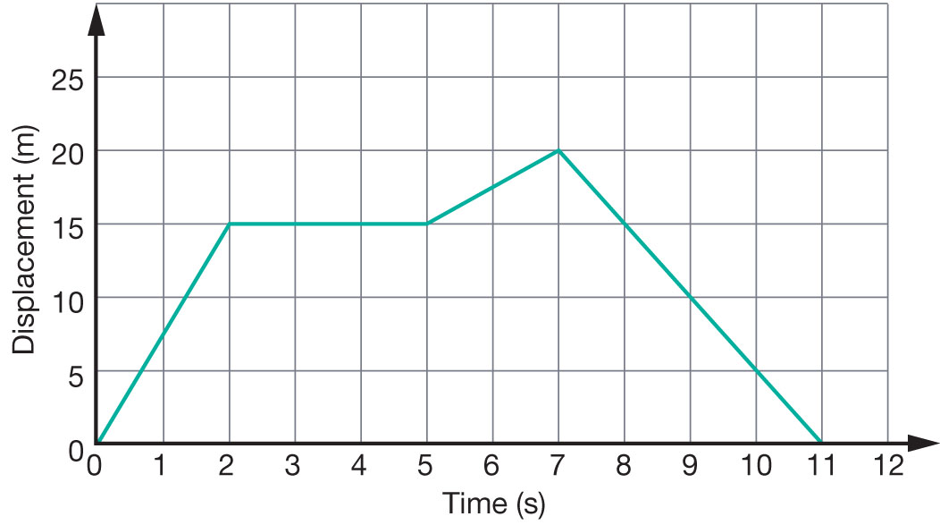
Figure 1
Displacement graph of a cat running down a laneway.
a Use Figure 1 to construct a velocity–time graph of the cat’s motion on the axis on the following page.
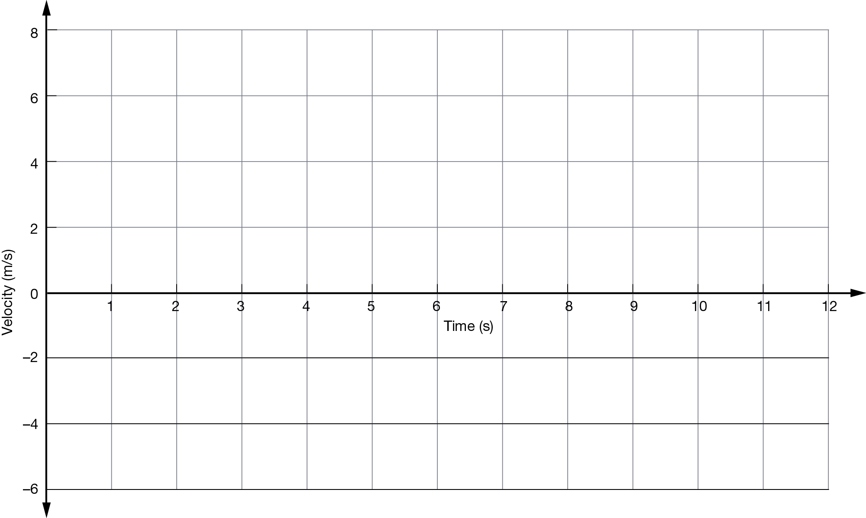
b Describe the motion of the cat as it runs along the laneway.

2 Figure 2 shows the motion of a cruise ship as it travels in a straight line route from the docks to its destination.
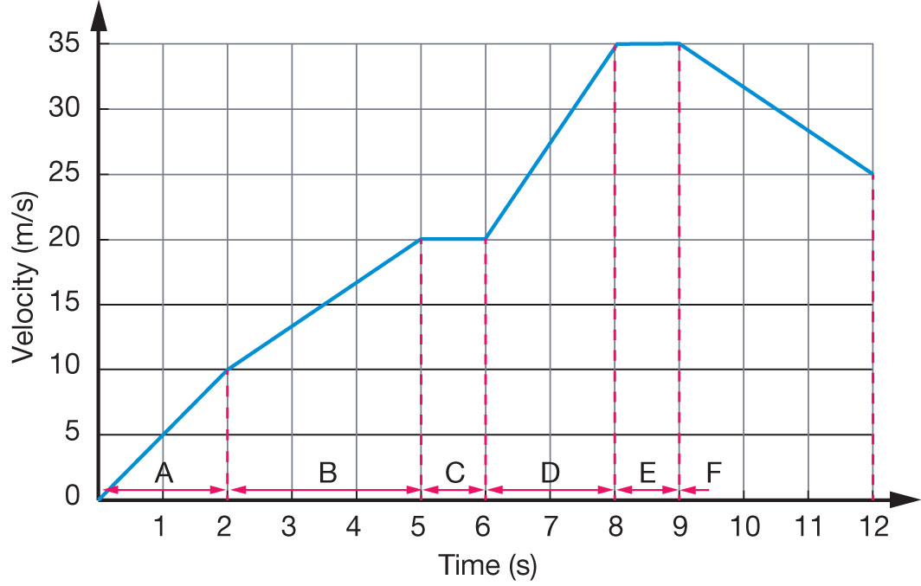
Figure 2
Motion of a cruise ship.
a Calculate the average acceleration of the ship in each of the sections marked A–F. Fill out your results in the table:
Section of motion | Average acceleration (m/s/s)
A
B
C
D
E
F
b Use your results from part a to construct an acceleration–time graph of the ship’s motion on the axes below:
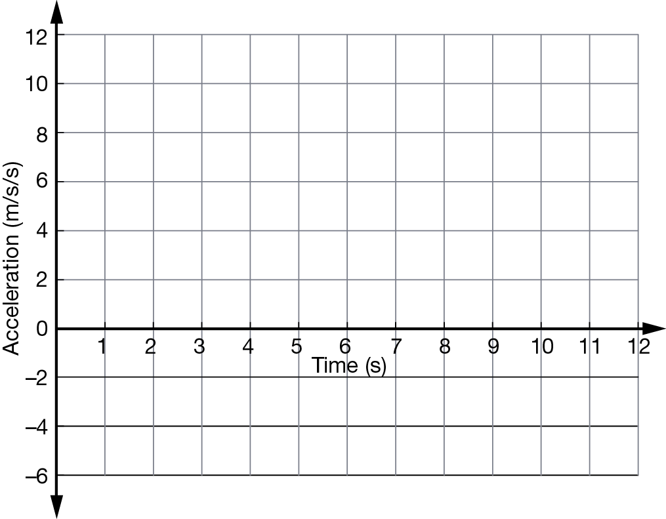
c Identify in which sections the ship is:
i speeding up:
ii slowing down:
iii travelling at a constant speed:
d Calculate the distance the ship sails in the first 5 seconds of its journey.

